NAME: ___________________________________ GROUP: _________
__________________________________________________________________

ENGLISH
YEAR TWO
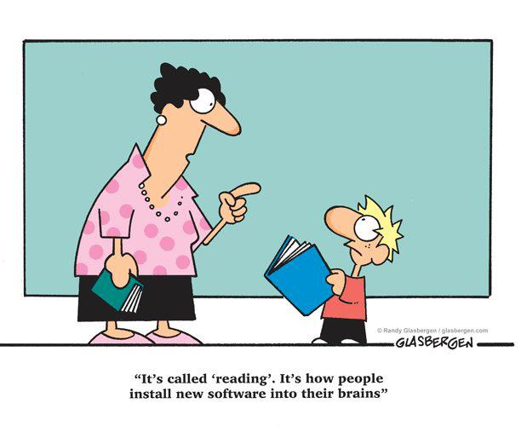
TERM 1

DATE: ____________________________ TOPIC: BACK TO SCHOOL (WEEK 1)
___________________________________________________________________
ACTIVITY 1 READING & VIEWING
ADVERTISEMENT
1.1 Read the following poster and complete comprehension questions.
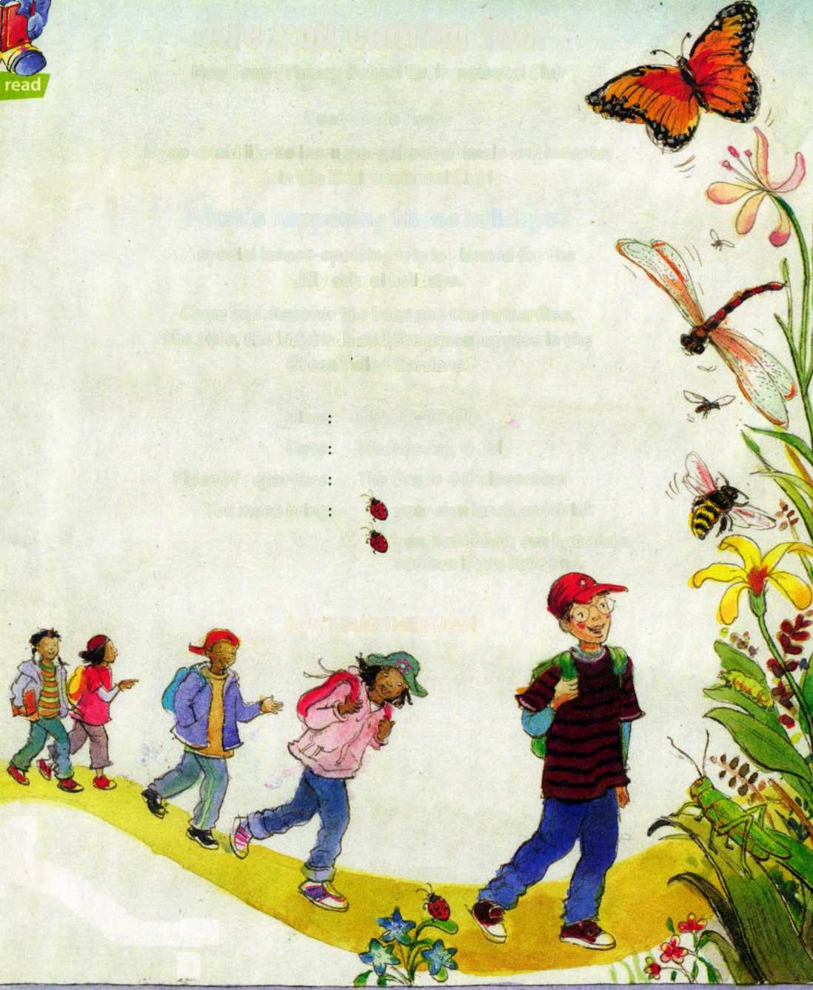

Are you coming too?
Olympia Park School Environmental Club
Dear Year Two’s
If you would like to learn more about animals and insects,
join the Environmental Club!

What's happening these holidays?
A special insect-spotting trip is planned for the
March school holidays.
Come and discover the bees and the butterflies,
the ants, the ladybirds and the grasshoppers in the
Green Valley Gardens.
Time: 09:00-16:00
Date: Wednesday, 26 March
Place of departure: Olympia Park School Hall
You must bring: your own lunch and drink
pen, notebook, sun hat and a camera if you have one.

DON'T BUG THE BUGS!

a) What trip were the Year Two learners invited to?
___________________________________________________________b) On what day and at what time will the trip start?
___________________________________________________________c) What must the children bring with them?
_________________________________________________________________________________________________________________________________________________________________________________d) Which headings attract your attention?
______________________________________________________________________________________________________________________e) What do the pictures tell us?
______________________________________________________________________________________________________________________f) What insects are mentioned in the poster?
______________________________________________________________________________________________________________________g) Circle the correct word in brackets.
This advertisement will attract the attention of (party lovers / nature lovers) h) If you join the environmental club, you will learn more about ________________________ and _________________________ i) Will you join Olympia Park School Environmental Club? Explain your answer.
______________________________________________________________________________________________________________________
1.2 Read the following advertisement and complete comprehension
questions.
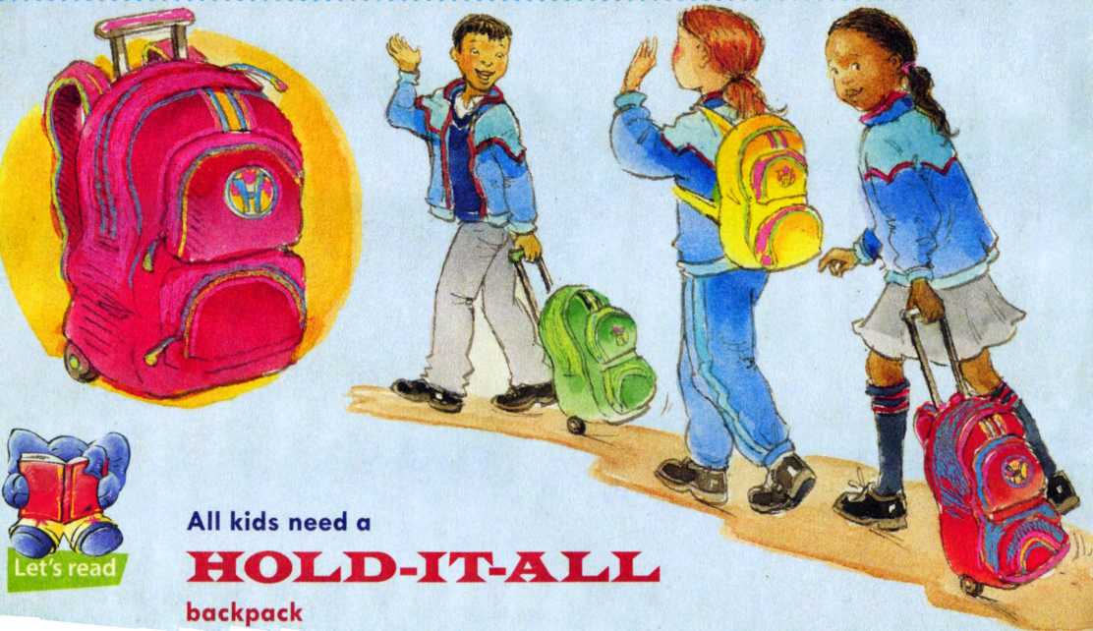

Are you going on a school trip?
Use the backpack made for kids!
Carry your things safely and in style.
Made of non-tear polyester, nylon and canvas,
this backpack is made to last.
Keep your books, pens, lunch pack etc. organised and hidden
in the . It has hidden pockets and
special compartments to keep your cell phone and money safe.
Zipper locks keep items as safe as a bank.
It has large wheels so you don’t need to carry the bag on your back.
Prices range from R70 to R100.
Everyone wants a backpack – so get yours
before it’s too late!
Circle the letter of the correct answer.
a) What product is being advertised?
A cell phone
B back pack
C Lunch pack
b) Who is the advertisement aimed at?
A old people
B teenagers
C school children
c) Which of these is NOT mentioned in the advertisement?
A It has wheels
B It is colourful
C It has hidden pockets
d) What does “get yours before it’s too late” mean?
A They may sell out quickly
B They are very cheap
C Everyone should have one

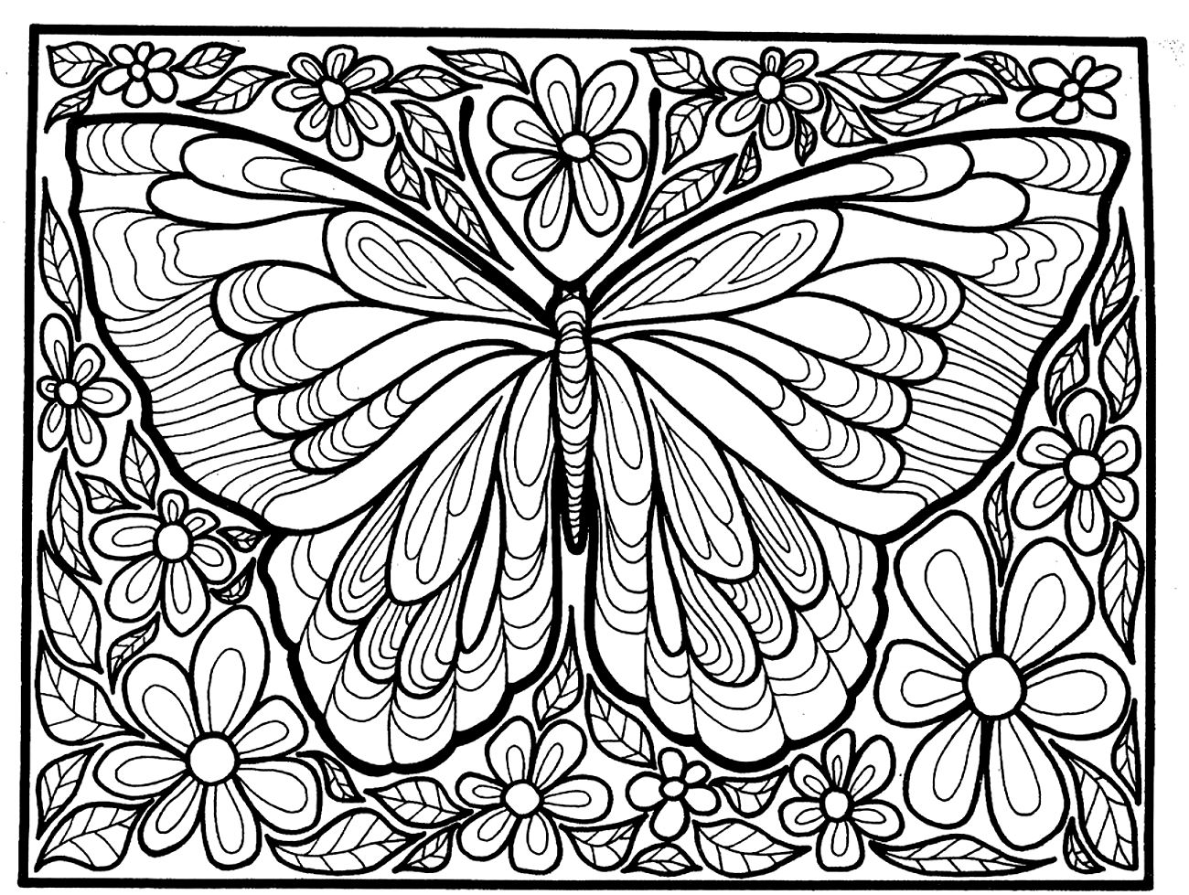

DATE: ____________________________ TOPIC: BACK TO SCHOOL (WEEK 1)
___________________________________________________________________
ACTIVITY 2 WRITING & PRESENTING
POSTER
Design a poster on the topic “Back to school”

DATE: ____________________________ TOPIC: BACK TO SCHOOL (WEEK 1)
___________________________________________________________________
ACTIVITY 3 LANGUAGE STRUCTURE & CONVENTIONS
COMPOUND WORDS
Single word | Single word | Compound word
rain | bow
back | pack
book | note
man | fire
bean | bag
pot | flower
dragon | fly
sun | flower
cake | pan
bag | hand
paint | brush
coat | rain
lady | bug
foot | ball
cow | boy
box | mail
school | bag
brush | tooth
cup | cake
lip | stick

DATE: ____________________________ TOPIC: THE TEAR THIEF (WEEK 2)
___________________________________________________________________
ACTIVITY 4 LISTENING & SPEAKING
MODERN FAIRYTALE: THE TEAR THIEF
Listen to your teacher reading “The tear thief”. Discuss the story. Give a short summary of the story in your own words (tell the class what the story is about).

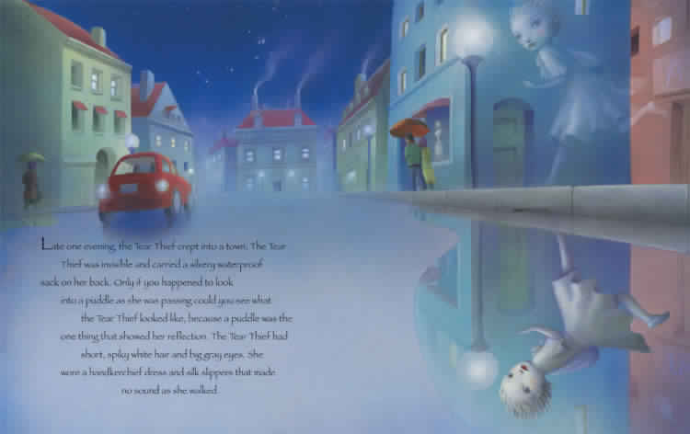
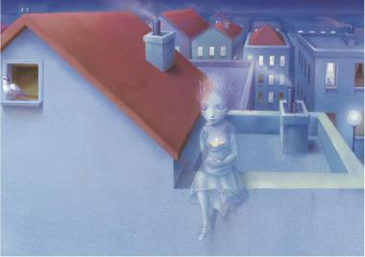
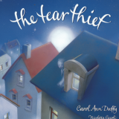

Summary
Have you heard about the tear thief? Every evening, she moves soundlessly about the town in her silk slippers, collecting children’s tears and popping them into her silvery waterproof sack. No-one can see her, because her reflection is only visible in puddles. Wherever she goes, she works a special magic, and the child she is visiting has no need to cry any more.
DATE: ____________________________ TOPIC: THE TEAR THIEF (WEEK 2)
___________________________________________________________________
ACTIVITY 5 LANGUAGE STRUCTURE & CONVENTIONS
CONTRACTIONS
1. The Tear Thief (is not) _____________visible.
2. The girl (was not) _______________sad any more.
3. You (are not) ____________funny.
4. They (were not) _____________ crying.
5. (Do not) ____________ cry over spilt milk.
6. We (did not) _____________see the Tear Thief.

ALPHABETICAL ORDER
Write the following compound words in alphabetical order.
rainbow toothbrush backpack schoolbag cowboy cupcake

______________________________________________________________________________________________________________________________________________________________________________________________________________________________________________________________________________________________________
a b c d e f g h i j k l m n o p q r s t u v w x y z a l p h a b e t
DATE: ____________________________ TOPIC: DO IT YOUR SELF (WEEK 3/4)
___________________________________________________________________
ACTIVITY 6 LISTENING & SPEAKING / READING / WRITING
INSTRUCTIONS
a) Listen to instructions on how to fold a paper airplane.
b) The following vocabulary is important when folding paper. Choose the correct meaning on the board for each word and complete the activity.
HORIZONTAL:
LEFT RIGHT
______________________________________________________________________________________________________________________
VERTICAL:
TOP

BOTTOM
______________________________________________________________________________________________________________________
CENTRE:

______________________________________________________________________________________________________________________
CORNERS:

______________________________________________________________________________________________________________________
TUCK IN:

______________________________________________________________________________________________________________________
EDGES:

______________________________________________________________________________________________________________________

c) Instructions for folding a paper airplane
You will need:
1. Paper
2. A pair of scissors
3. A ruler

Now look at the pictures and write instructions for folding a paper
airplane.
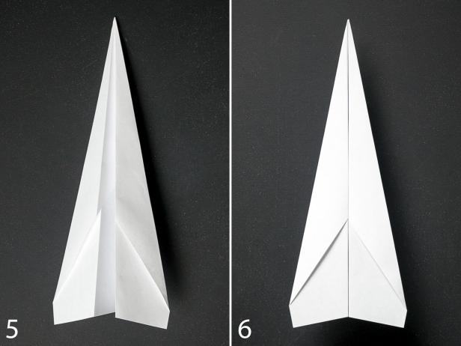
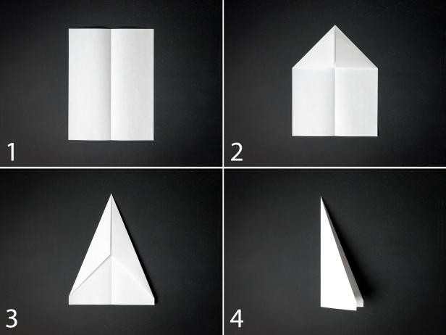

Instructions
_________________________________________________________________________________________________________________________________________________________________________________________________________________________________________________________________________________________________________________________________________________________________________________________________________________________________________________________________________________________________________________________________________________________________________________________________________________________________________________________________________
DATE: ____________________________ TOPIC: DO IT YOUR SELF (WEEK 3/4)
___________________________________________________________________
ACTIVITY 7 WRITING & PRESENTING
INSTRUCTIONS
Put the instructions in the correct order.
How to make a paper hat

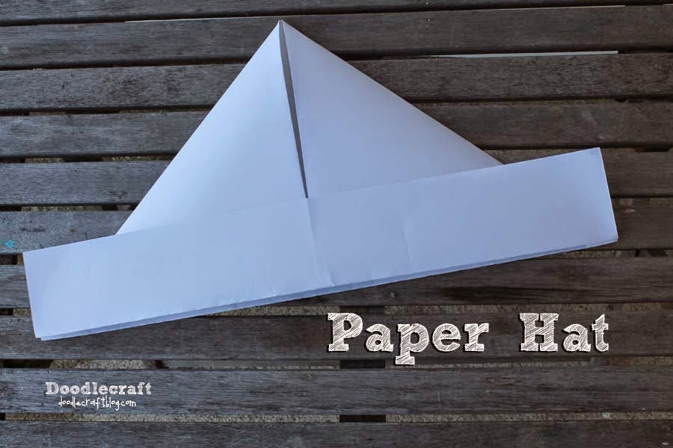

- Use a piece of elastic to hold the hat in place.
- Fold right and left sides towards the middle to form a point.
- Open bottom and fold bottom up on back and front.
- Fold newspaper in half.
- Fold top down to meet bottom.

1. ________________________________________________
2. ________________________________________________
________________________________________________
3. ________________________________________________
4. ________________________________________________
________________________________________________
5. ________________________________________________
DATE: ____________________________ TOPIC: DO IT YOUR SELF (WEEK 3/4)
___________________________________________________________________
ACTIVITY 8 LANGUAGE STRUCTURE & CONVENTIONS
Compound words
1. Go to your (class + room) _____________________
2. The (fire + man) _______________ puts out the fire.
3. My father reads the (news + paper) __________________
4. I like a sweet (pan + cake) ___________________
5. My favourite flower is the (sun + flower) ___________________

Rewrite the sentences and correct the spelling errors.
1. I made notes in my note book.
_______________________________________________________
2. My back pack was very heavy.
_______________________________________________________
3. She bought a new school bag.
_______________________________________________________
4. He had cup cakes in his lunch tin.
________________________________________________________
5. I wore my rain coat on rainy days.
________________________________________________________
DATE: ____________________________ TOPIC: THE GAMES WE PLAY (WEEK 5)
___________________________________________________________________
ACTIVITY 9 LISTENING & SPEAKING
Take part in discussion on pictures of children playing games.

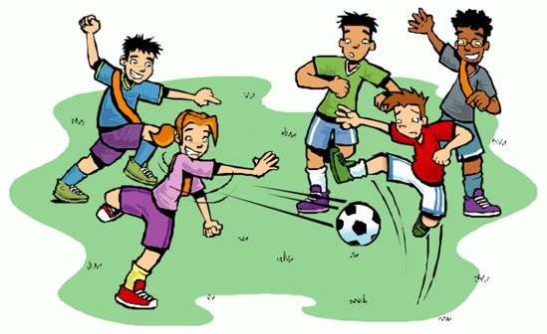
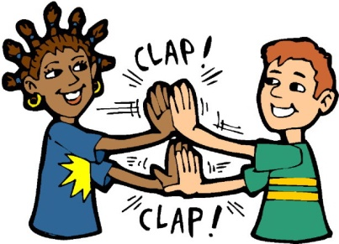
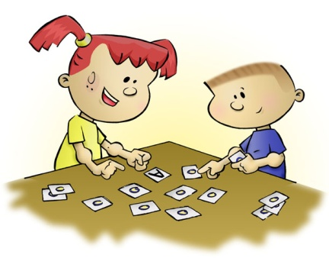

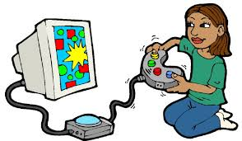
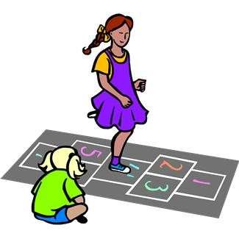
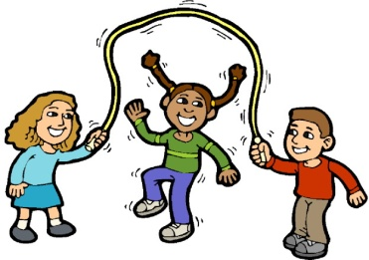

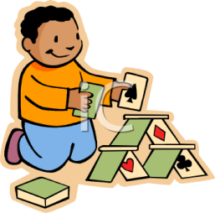
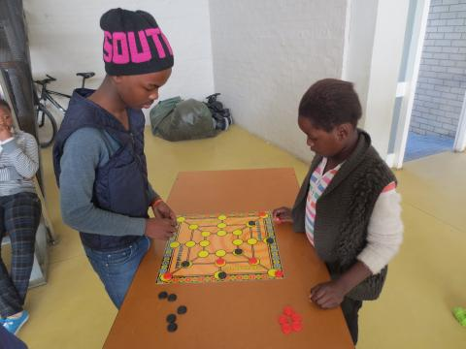


DATE: ____________________________ TOPIC: THE GAMES WE PLAY (WEEK 5)
___________________________________________________________________
ACTIVITY 10 READING & VIEWING
Reading a procedural text
Morabaraba an African board game
Morabaraba (or umlabalaba) is a popular board game for two players.
The game was often played by boys herding cattle.
They drew the board on the ground. They played with stones.
You will need:
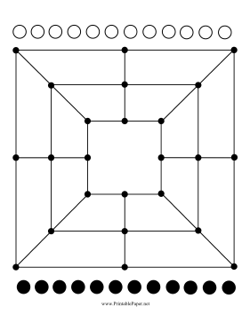
A board
12 small black stones
12 small white stones

Instructions: Fill in the missing words.
1. Each player has 12 ______________, called ‘cows’.
2. The player with the _______________ stones begins.
3. Each player takes a turn to put a _________ in an empty circle on the board.
4. The __________ of the game is to make rows of three cows on the board.
5. When a player makes a ___________ of three cows, the player may then ‘shoot’ or take one of the other player’s cows off the board.
6. ____________ all the cows are on the board, a player can move a cow from one circle to the one _____________ ______ it.
7. The game _________________ when one player cannot move any cows or has only two cows left.
Answer comprehension questions
1. Who plays first in this game?
___________________________________________________________
2. What is a cow in this game?
________________________________________________________
3. Where do the players put the stones?
________________________________________________________
________________________________________________________
4. What is the aim of the game?
________________________________________________________
________________________________________________________
5. How can you win the game?
_________________________________________________________
________________________________________________________
6. Why do you think the stones are called cows in this game?
________________________________________________________
________________________________________________________

DATE: ____________________________ TOPIC: OUR COUNTRY (WEEK 5)
___________________________________________________________________
ACTIVITY 11 READING & VIEWING
Read the following text individually for information.

NELSON MANDELA’S AUTOBIOGRAPHY
From the dusty fields of Qunu in Eastern Cape, Nelson Mandela grew to become a wise and admirable man, respected and loved around the world. He is a man of integrity, who is known for his love for children. His influence on a global scale is massive, but just as significant has been his emphasis on the importance of family.
Mandela is called the father of the nation perhaps not only for his role in liberating South Africans but also for the love and support he has shown to its children.
During his term as president, Mandela gave half his salary to the poor, specifically to children.
Through the Nelson Mandela Children's Fund, funds are raised and programmes are initiated to ensure a better future for children.
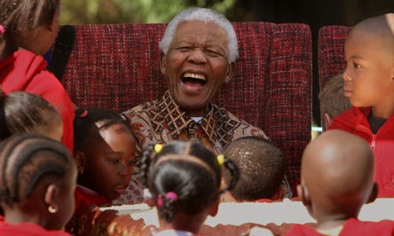
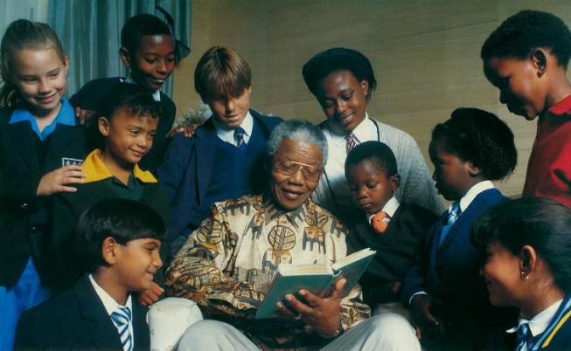
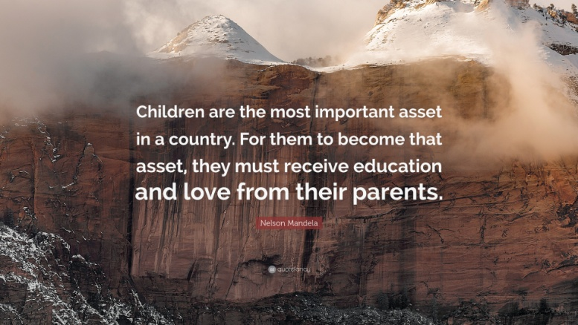
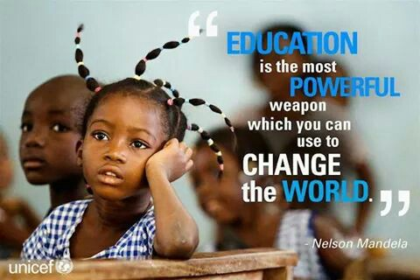
History will judge us by the difference we make in the everyday lives of children.

READING COMPREHENSION
a) Where did Nelson Mandela grew up?
___________________________________________________________b) Complete the sentence:
Nelson Mandela is known for his ______________ for children.
He places great emphasis on the importance of _____________
Nelson Mandela is called the _____________ of the _____________
c) During his term as president, Nelson Mandela did something to show his support of the poor people of South Africa. What was that?
______________________________________________________________________________________________________________________
d) How will History judge us according to Nelson Mandela?
______________________________________________________________________________________________________________________
e) What is the most powerful weapon you can use to change the world?
___________________________________________________________
f) What would you do to uplift our country if you were the president?
__________________________________________________________________________________________________________________________________________________________________________________________________________________________________________________________________________________________________________________________________________________________________
DATE: ____________________________ TOPIC: OUR COUNTRY (WEEK 5)
___________________________________________________________________
ACTIVITY 12 LANGUAGE STRUCTURE & CONVENTIONS
Combine sentences using conjunctions.
a) Mandela is called the father of the nation. He loved and supported the children.
because
_________________________________________________________________________________________________________________________________________________________________________________
and
b) He is respected. He is loved around the world.
______________________________________________________________________________________________________________________
c) Children are the most important asset in a country. They must be looked after.
and so
_________________________________________________________________________________________________________________________________________________________________________________
until
d) Mandela gave half his salary to the poor. The day he retired.
______________________________________________________________________________________________________________________
but
e) Nelson Mandela was a strict man. He was a fair man.
______________________________________________________________________________________________________________________

Examples of BACK-TO-SCHOOL advertisements


PLUS

your share of
R 100 000
in cash prizes for school fees!
To Enter:
Simply SMS “Trust BIC” to 3501

BUY ME
& BIC
WILL DONATE
1 PEN
This back to school period –
for every pack sold with this sticker,
BIC will donate a pen to a child in need



Oil and Filter Service
With Free Tire Rotation

From 1 January to 1 February


